AUBURN MEADOW COMMUNITY ASSOCIATION  
SPRING/SUMMER NEWSLETTER  
2018

**WELCOME TO OUR NEW RESIDENTS!!!!!**

|  |
| --- |
| **Community Board Members:**  **Elaine Patmore, President**  **Marshall Miller, Treasurer**  **Ruth Polito, Secretary**  **Directors:**  **Marina Cook**  **Adriana Giambelluca**  **Lucy Johnston**  **Greg Mucha**  **Kathy Oppolo**  **Barbarta Sakowski** |
|  |
|  |

GREAT TIME HAD BY ALL AT THE COMMUNITYPAINT AND SIP EVENT HOSTED B KATHIE PENKALA AND PAT PIAZZA

AUBURN MEADOW COMMUNITY CONTACT

Carolin Kenneally from Region Elite Property Management lp is our Property Manager and is generally available at the clubhouse on Monday, Tuesday, and thursday from 7am to 2pm. **please call FIRST to schedule an appointment. Office will be closed june 29th through july 6th .**

### Carolin’s contact information is listed below:

### Mobile phone: (219) 308-5191

### Email: [community@auburnmeadow.comcastbiz.net](mailto:community@auburnmeadow.comcastbiz.net)

### *(If you want to receive community updates please provide your email address to carolin)*

**THANK YOU TO OUR VOLUNTEERS**

**Board Volunteers**

Thanks to all members of all the boards, past and **present, who devote time and effort into** maintaining our Community.

**A BIG Thank you goes out to Barbara Sakowski for continuing to organize the Book Club!!  
The Book Club Meets the Second Tuesday of every month at 12:45PM and 6:45PM**





**Community Pool News:**

**You will need your key fob to get in and out of pool area through the bathrooms at all times. Please do not enter pool area without your key fob or you will be stuck!!**

**YOU MUST EXIT POOL AREA BY 9:00PM OR YOU WILL BE LOCKED IN!**

Our community pool is open from Memorial Day weekend thru Labor Day weekend. The daily hours are 9:00 AM to 9:00 PM thru July, changing to 9:00 AM to 8:00 PM during August. Please note the rules that pertain to this area. No food or drinks or alcohol are permitted.

NOTICE REGARDING OUR CLUBHOUSE

All assessments can be easily dropped off on our secure drop box located by the clubhouse front door.

CLUBHOUSE ACCESS

For all our new residents throughout the community, please call Carolin to request a “fob” which will permit you to use our exercise room, bathrooms and pool. There is a reader at the west entrance to the clubhouse which will unlock the door to permit entrance to our public area and readers on the bathroom doors to get in and out of pool area.

RULES AND REGULATIONS

Rules and regulations for the Association’s common area are posted throughout the community. Homeowner key fob access to the clubhouse will be de-activated for those that are behind in their dues and for those that violate the rules. If your key fob has been deactivated you are restricted from entering the clubhouse with any other resident or for any other reason.  There will be a $35.00 charge to re-activate key-fob once dues are paid in full or violation has been remedied.

Please be aware that these rules that are put in place for the safety of our residents and protection of our common areas.

EXERCISE ROOM

Please note the hours for our exercise room is 5:00 AM to 10:00 PM. Your fob will not unlock the west entrance door earlier or later than these hours. If you open any windows, please make sure and close them.

CLUBHOUSE RENTAL

Any Auburn Meadow resident can rent our clubhouse for various occasions. Application forms are posted on the bulletin board between the bathrooms in the west hallway. The cost is $125.00 for the rental. A separate check for $100.00 is required as a security deposit. Once the clubhouse has been inspected after your party, if it is clean and not damaged, the $100.00 check will be returned. You may rent this facility for up to twelve hours, 9:00 AM to 9:00 PM.

Please note: we are a non-profit and no exchange of money is permitted at clubhouse activities-no charge for **profit** or commercial endeavors is permitted.

**Please join the Ladies game day gathering every Tuesday at the clubhouse from 2:00pm to 4:00pm**

Geese Control

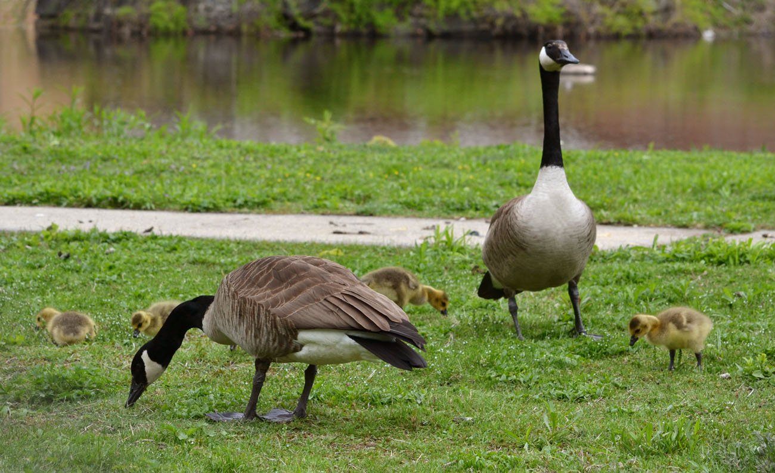

Geese are not "pets" but wild fowl, and thus carry various diseases.  Also, when you

feed them, you encourage them to return to our area.  Their feces are also disease carrying and are all over our lawns.

They are also very "aggressive" especially when they have babies.

Maintenance has been cleaning the path weekly to allow residents to enjoy the walking path.

*We are in need of Volunteers to HELP WITH THE POOL AND plan Community Activities or Events*

*Resident in good standing can volunteer to assist in preparing the pool area, please contact Carolin for information!!*

**HAVE A WONDERFUL SUMMER!!!!**