AUBURN MEADOW PAIRED COTTAGE ASSOCIATION
SUMMER NEWSLETTER
2018
Auburn Meadow Paired Cottage Board of Directors:
Lucy Johnston-President/Secretary
Marshall Miller-Treasurer
Greg Mucha-Director
Carol Shaykin- Director
Don Shaykin-Director

PROJECTS FOR 2018
All driveways wil be seal-coated this year in May if weather permits.
PRUNING OF SHRUBS:
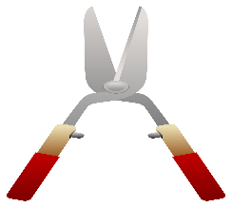
REMINDER: We have had requests from some residents to opt out of the association’s pruning. It was decided that residents will not be permitted to opt out of the pruning that is provided by the association twice a year. The pruning is included in your monthly dues and it is needed in order to keep uniformity, as well as, to maintain property values. Homeowners are permitted to touch up themselves, however, no one is permitted to opt out of this service.
DEAD SHRUBS/PLANTINGS:
The Association will replace dead shrubs / plantings that were originally installed by the Developer in the front elevation. Please contact Carolin at community@auburnmeadow.comcastbiz.net to request replacement on completely dead shrubs. The association will replace with shrubs better suited for the area.
IRRIGATION
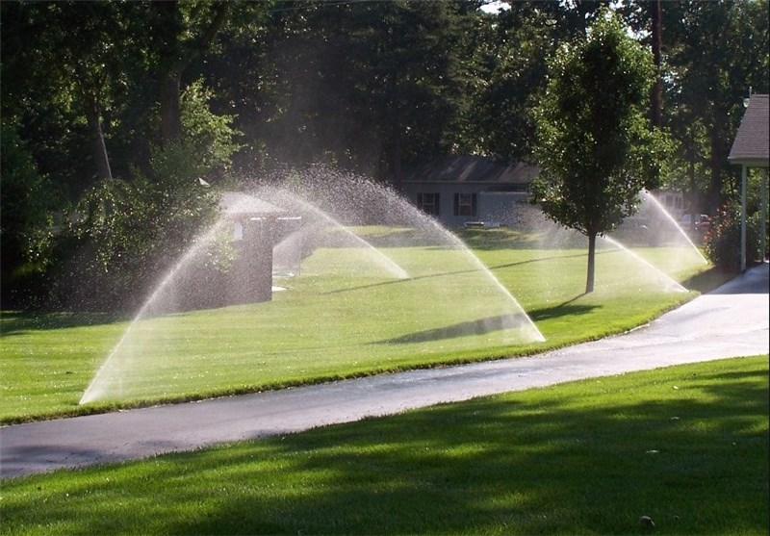
If you have the turn on switch for the irrigation inside your home please have it turned on by May 1st. The irrigation start-up will be completed in May; however, the water will not be turned on for sprinkling until it is needed. Once you see the water turned on for sprinkling please quickly review your property and notify Carolin @ community@auburnmeadow.comcastbiz.net or at 219-308-5191 of any broken sprinkler heads or directional issues.
If you see a sprinkler that is stuck in a popped-up position please push back down so lawn mowers will not damage.
ALL CHANGES TO YOUR HOME’S EXTERIOR OR LANDSCAPE MUST BE PRE-APPROVED BY YOUR BOARD OF DIRECTORS (ARC COMMITTEE) For many of our new residents, this may be the first time you have lived in a ‘COMMUNITY” situation. In order to keep our neighborhood coordinated in a consistent style and keep our property values up, whenever you are considering making changes to the exterior of your unit or landscape, you are required to submit a request to Carolin by placing in the clubhouse drop box. The form for this request can be found in the west hallway of our clubhouse on the bulletin board between the bathrooms. When applying for an ARC approval, please provide a written description and diagram with detailed measurements with your application and proposal from licensed contractor if available. This will expedite the processing of your request. Please note that residents are responsible for contacting irrigation company to move any sprinkler head in the way at their own expense.
FRIENDLY REMINDERS:
Please do not place bird feeders by your privacy fence
Please do not hang anything on privacy fence
Please keep pets restrained at all times and clean up immediately after them
Please place your garbage receptacles in garage within 24 hours after pick up
.
ALLOWABLE ITEM GUIDELINES-FRONT ELEVATION:
- Landscape lights in rock only-limit eight (8) lights
- Shepard’s hook with hanging flower pot-one only (double hook allowed)
- 6 flower pots with live flowers/plants only (no artificial)-in rock area, on front porch or by front door.
- American flag that is attached to residential unit or flag pole that is secured in concrete
- Figurines-limit two (2) –maximum height 48” tall-no plastic figurines (plaster , cement or resin only)
- Lighted address signs- 12 inches tall
- Holiday decorations are allowed however must be removed within reasonable amount of time (2 weeks after holiday)
- Sun Globes/ Gazing Balls-limit one (1) Must be on secure globe stand
WHAT TO EXPECT
- Forever Green will apply the 1st round of Fertilization
April
- Spring clean-up and mowing will start
May
- All driveways will be seal-coated
- Thomas Irrigation will be out to open the irrigation system
- Forever Green will apply the 2nd round of Fertilization
June
- Shrub pruning on certain shrubs in front elevation will be done
July
  - Forever Green will apply the 3rd round of Fertilization as well as grub control application.
September

  - Forever Green will do the 4th round of Fertilization
October
  - Forever Green will apply the 5th round of fertilization
  - Annual meeting will be held in early October
  - Shrub pruning
November
- Fall clean-up usually every other week -leaves will be blown out of landscape beds and mulched up every other week.
December
- Gutter cleaning
- Rose bush and long grass pruning will be done in December up until March.

THANK YOU AND MAKE IT A SUMMER!!

