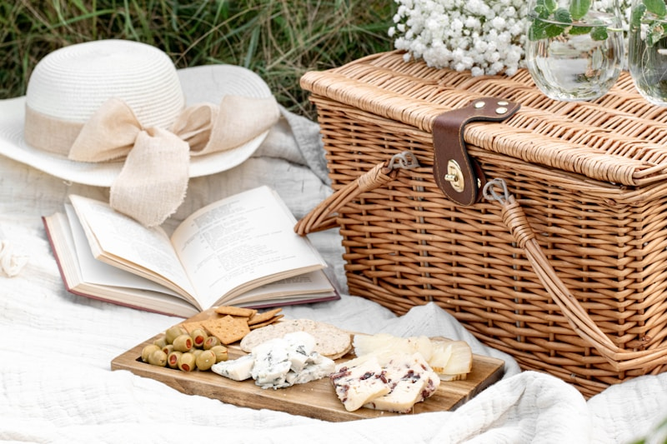

[This Photo](https://serokui987.tistory.com/entry/%EC%97%AC%EB%A6%84-%EC%9D%8C%EC%8B%9D%EC%9D%84-%EC%A6%90%EA%B8%B0%EB%8A%94-10%EA%B0%80%EC%A7%80-%EB%B0%A9%EB%B2%95-%EC%83%81%ED%81%BC%ED%95%98%EA%B3%A0-%EC%8B%9C%EC%9B%90%ED%95%9C-%EC%97%AC%EB%A6%84-%EB%A0%88%EC%8B%9C%ED%94%BC-%EB%AA%A8%EC%9D%8C) by Unknown Author is licensed under [CC BY-NC-ND](https://creativecommons.org/licenses/by-nc-nd/3.0/)

**Greens of Scherwood Neighborhood Picnic**

**SUNDAY – AUGUST 24, 2025**

**NOON till ?**

**Come celebrate with us and meet with your neighbors under the pavilion at the golf course. If it rains, we will celebrate inside the clubhouse.**

**FRIED CHICKEN, ITALIAN SAUSAGE, SODA AND WATER**

**We ask if you could bring a favorite potluck dish or dessert to serve at the event. There is no obligation – we want everyone to attend even if you don’t bring a side dish of any kind.**

**Please RSVP no later than August 18, 2025. Sign up calls are being taken by Joyce Mills at 219-333-6444 you are attending and/or going to bring a side dish.**

**IMPORTANT to RSVP - If you leave a message on Joyce’s phone, please state your full name and address so we know who you are. A count is needed to put in the food order.**

**In addition, this year there will be bean bag toss and bingo games with prizes!**